Assignment 3a – Extraction

**Query 1**

Shows Data of a worker and its warehouse, the worker works in.

**Query 2**

Shows Data about each warehouse. It specifically shows which printers are inside of each warehouse and shows also data about the printers. Additionally, we get all plans a printer is associated with.

**Query 3**

For every artist we get the plans he/she is associated with and, we get for each of these plans the one worker, who is responsible for this plan.

**Query 3**

This query shows specific info about a worker. We see all the shopping items the worker created (that he/she wants to buy) and all the plans the worker is responsible for.

For every query we limit the output to 100, so that we don’t get to much data back and also the queries are faster. If all data is needed, the (limit 100) clause needs to be removed from each query.

# Query 1

SQL

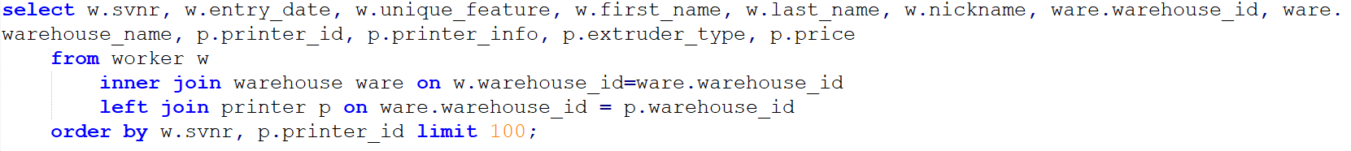

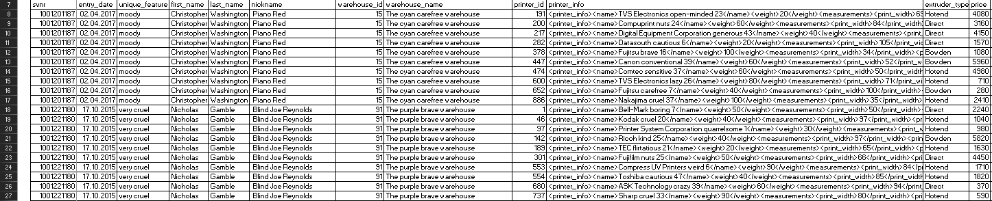

SQLXML

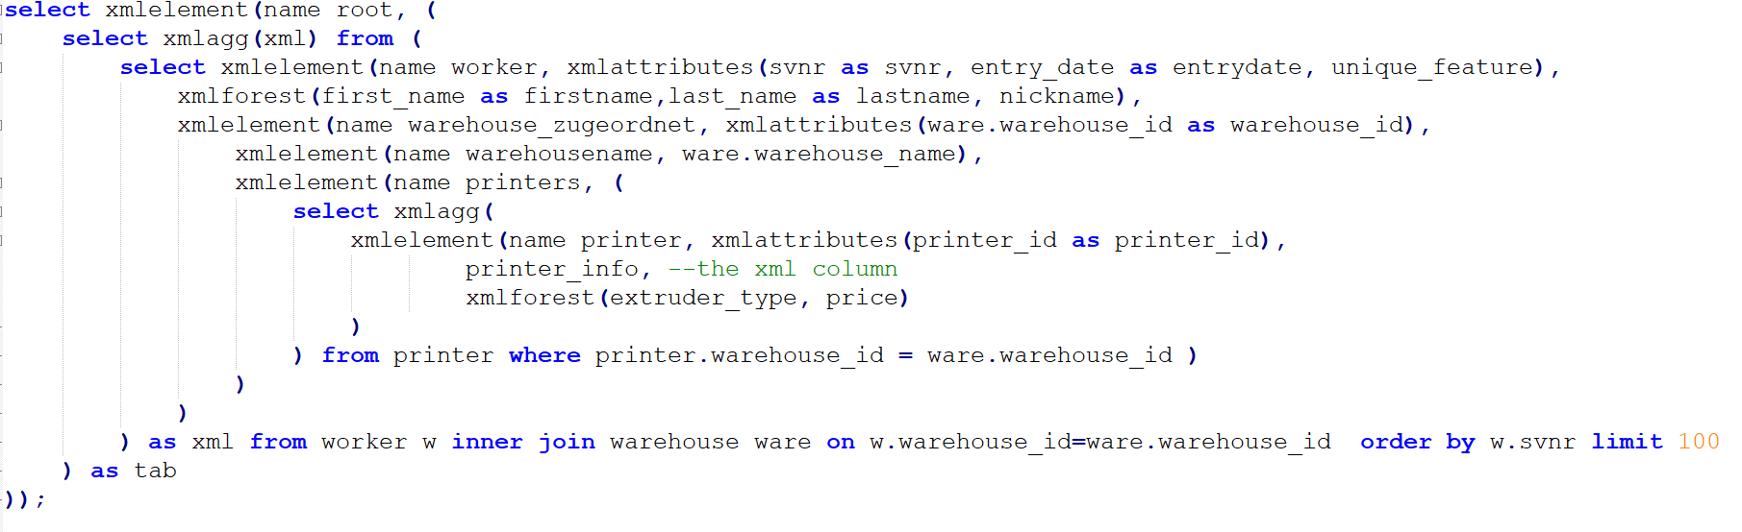

<worker svnr="1001201187" entrydate="2017-04-02" unique_feature="moody">

<firstname>Christopher</firstname>

<lastname>Washington</lastname>

<nickname> Piano Red</nickname>

<warehouse_zugeordnet warehouse_id="15">

<warehousename>The cyan carefree warehouse</warehousename>

<printers>

<printer printer_id="191">

<printer_info>

<name>TVS Electronics open-minded 23</name>

<weight>20</weight>

<measurements>

<print_width>69</print_width>

<print_depth>106</print_depth>

<print_height>13</print_height>

</measurements>

</printer_info>

<extruder_type>Hotend</extruder_type>

<price>4080</price>

</printer>

<printer printer_id="200">

<printer_info>

<name>Compuprint nuts 24</name>

<weight>60</weight>

<measurements>

<print_width>84</print_width>

<print_depth>77</print_depth>

<print_height>38</print_height>

</measurements>

</printer_info>

<extruder_type>Direct</extruder_type>

<price>3160</price>

</printer>

<printer printer_id="217">

<printer_info>

<name>Digital Equipment Corporation generous 43</name>

<weight>40</weight>

<measurements>

<print_width>44</print_width>

<print_depth>75</print_depth>

<print_height>12</print_height>

</measurements>

</printer_info>

<extruder_type>Direct</extruder_type>

<price>4150</price>

</printer>

<printer printer_id="282">

<printer_info>

<name>Datasouth cautious 6</name>

<weight>20</weight>

<measurements>

<print_width>105</print_width>

<print_depth>89</print_depth>

<print_height>10</print_height>

</measurements>

</printer_info>

<extruder_type>Direct</extruder_type>

<price>1570</price>

</printer>

<printer printer_id="378">

<printer_info>

<name>Fujitsu brave 16</name>

<weight>100</weight>

<measurements>

<print_width>34</print_width>

<print_depth>90</print_depth>

<print_height>34</print_height>

</measurements>

</printer_info>

<extruder_type>Bowden</extruder_type>

<price>1080</price>

</printer>

<printer printer_id="447">

<printer_info>

<name>Canon conventional 39</name>

<weight>60</weight>

<measurements>

<print_width>52</print_width>

<print_depth>103</print_depth>

<print_height>15</print_height>

</measurements>

</printer_info>

<extruder_type>Bowden</extruder_type>

<price>5960</price>

</printer>

<printer printer_id="474">

<printer_info>

<name>Comtec sensitive 37</name>

<weight>60</weight>

<measurements>

<print_width>50</print_width>

<print_depth>18</print_depth>

<print_height>48</print_height>

</measurements>

</printer_info>

<extruder_type>Hotend</extruder_type>

<price>4980</price>

</printer>

<printer printer_id="600">

<printer_info>

<name>TVS Electronics lazy 26</name>

<weight>80</weight>

<measurements>

<print_width>71</print_width>

<print_depth>102</print_depth>

<print_height>28</print_height>

</measurements>

</printer_info>

<extruder_type>Hotend</extruder_type>

<price>710</price>

</printer>

<printer printer_id="652">

<printer_info>

<name>Fujitsu carefree 7</name>

<weight>40</weight>

<measurements>

<print_width>100</print_width>

<print_depth>77</print_depth>

<print_height>28</print_height>

</measurements>

</printer_info>

<extruder_type>Bowden</extruder_type>

<price>280</price>

</printer>

<printer printer_id="886">

<printer_info>

<name>Nakajima cruel 37</name>

<weight>100</weight>

<measurements>

<print_width>35</print_width>

<print_depth>66</print_depth>

<print_height>12</print_height>

</measurements>

</printer_info>

<extruder_type>Hotend</extruder_type>

<price>2410</price>

</printer>

</printers>

</warehouse_zugeordnet>

</worker>

<worker svnr="1001221180" entrydate="2015-10-17" unique_feature="very cruel">

<firstname>Nicholas</firstname>

<lastname>Gamble</lastname>

<nickname> Blind Joe Reynolds</nickname>

<warehouse_zugeordnet warehouse_id="91">

<warehousename>The purple brave warehouse</warehousename>

<printers>

<printer printer_id="1">

<printer_info>

<name>Bell-Mark boring 7</name>

<weight>50</weight>

<measurements>

<print_width>50</print_width>

<print_depth>92</print_depth>

<print_height>40</print_height>

</measurements>

</printer_info>

<extruder_type>Direct</extruder_type>

<price>2240</price>

</printer>

<printer printer_id="46">

<printer_info>

<name>Kodak cruel 20</name>

<weight>40</weight>

<measurements>

<print_width>97</print_width>

<print_depth>28</print_depth>

<print_height>12</print_height>

</measurements>

</printer_info>

<extruder_type>Hotend</extruder_type>

<price>1040</price>

</printer>

<printer printer_id="97">

<printer_info>

<name>Printer System Corporation quarrelsome 1</name>

<weight>30</weight>

<measurements>

<print_width>82</print_width>

<print_depth>94</print_depth>

<print_height>39</print_height>

</measurements>

</printer_info>

<extruder_type>Hotend</extruder_type>

<price>980</price>

</printer>

<printer printer_id="142">

<printer_info>

<name>Ricoh kind 25</name>

<weight>40</weight>

<measurements>

<print_width>97</print_width>

<print_depth>48</print_depth>

<print_height>27</print_height>

</measurements>

</printer_info>

<extruder_type>Bowden</extruder_type>

<price>5820</price>

</printer>

<printer printer_id="189">

<printer_info>

<name>TEC flirtatious 21</name>

<weight>20</weight>

<measurements>

<print_width>65</print_width>

<print_depth>94</print_depth>

<print_height>49</print_height>

</measurements>

</printer_info>

<extruder_type>Hotend</extruder_type>

<price>1630</price>

</printer>

<printer printer_id="301">

<printer_info>

<name>Fujifilm nuts 25</name>

<weight>50</weight>

<measurements>

<print_width>66</print_width>

<print_depth>30</print_depth>

<print_height>17</print_height>

</measurements>

</printer_info>

<extruder_type>Direct</extruder_type>

<price>4450</price>

</printer>

<printer printer_id="553">

<printer_info>

<name>Compress UV Printers weird 6</name>

<weight>90</weight>

<measurements>

<print_width>84</print_width>

<print_depth>74</print_depth>

<print_height>14</print_height>

</measurements>

</printer_info>

<extruder_type>Hotend</extruder_type>

<price>1710</price>

</printer>

<printer printer_id="554">

<printer_info>

<name>Toshiba cautious 47</name>

<weight>40</weight>

<measurements>

<print_width>85</print_width>

<print_depth>112</print_depth>

<print_height>14</print_height>

</measurements>

</printer_info>

<extruder_type>Hotend</extruder_type>

<price>1820</price>

</printer>

<printer printer_id="680">

<printer_info>

<name>ASK Technology crazy 39</name>

<weight>60</weight>

<measurements>

<print_width>94</print_width>

<print_depth>37</print_depth>

<print_height>22</print_height>

</measurements>

</printer_info>

<extruder_type>Direct</extruder_type>

<price>370</price>

</printer>

<printer printer_id="737">

<printer_info>

<name>Sharp cruel 33</name>

<weight>90</weight>

<measurements>

<print_width>80</print_width>

<print_depth>104</print_depth>

<print_height>26</print_height>

</measurements>

</printer_info>

<extruder_type>Hotend</extruder_type>

<price>590</price>

</printer>

<printer printer_id="742">

<printer_info>

<name>Ricoh cowardly 26</name>

<weight>100</weight>

<measurements>

<print_width>24</print_width>

<print_depth>10</print_depth>

<print_height>31</print_height>

</measurements>

</printer_info>

<extruder_type>Direct</extruder_type>

<price>5960</price>

</printer>

<printer printer_id="753">

<printer_info>

<name>GENICOM shy - introverted 2</name>

<weight>50</weight>

<measurements>

<print_width>26</print_width>

<print_depth>46</print_depth>

<print_height>41</print_height>

</measurements>

</printer_info>

<extruder_type>Bowden</extruder_type>

<price>4440</price>

</printer>

<printer printer_id="977">

<printer_info>

<name>Kyocera Mita quarrelsome 39</name>

<weight>80</weight>

<measurements>

<print_width>108</print_width>

<print_depth>92</print_depth>

<print_height>36</print_height>

</measurements>

</printer_info>

<extruder_type>Direct</extruder_type>

<price>3560</price>

</printer>

</printers>

</warehouse_zugeordnet>

</worker>

</root>

# Query 2

SQL

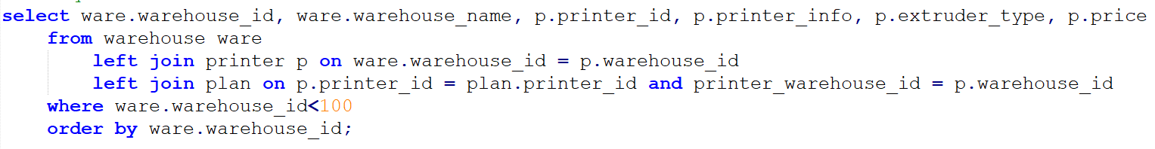

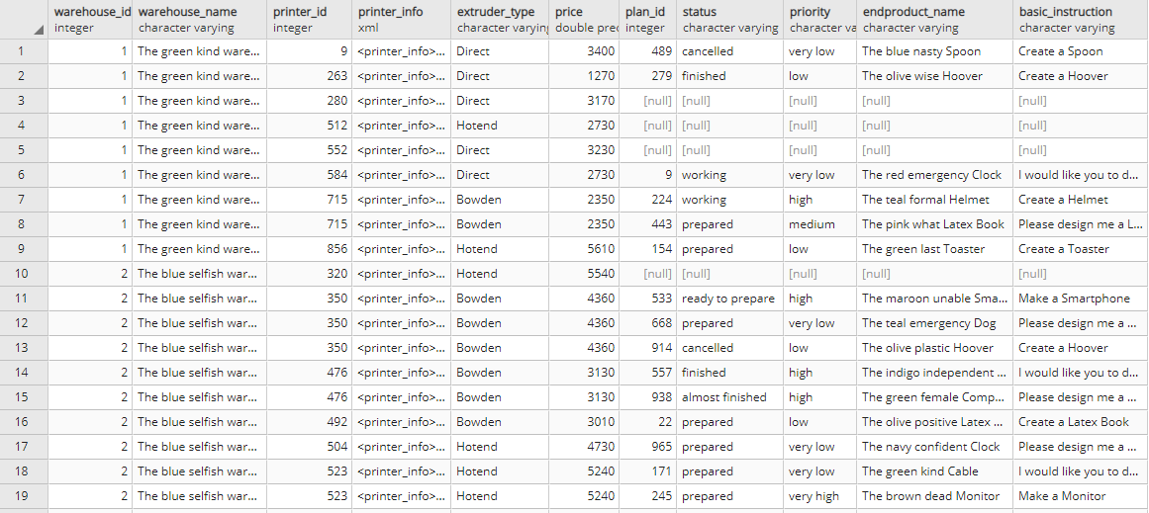

XMLSQL

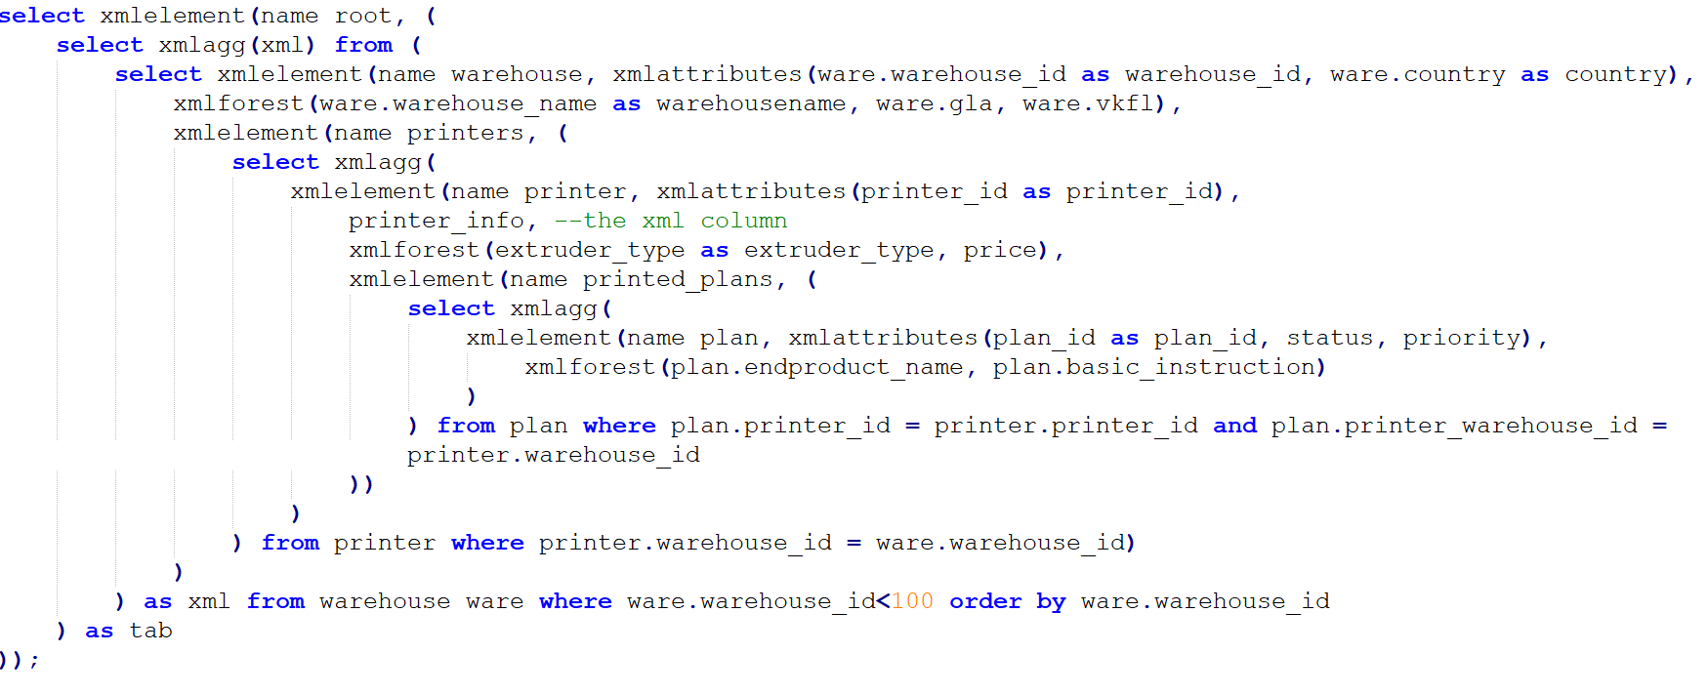

<root>

<warehouse warehouse_id="1" country="Austria">

<warehousename>The green kind warehouse</warehousename>

<gla>3600</gla>

<printers>

<printer printer_id="9">

<printer_info>

<name>Compuprint conventional 44</name>

<weight>30</weight>

<measurements>

<print_width>52</print_width>

<print_depth>49</print_depth>

<print_height>48</print_height>

</measurements>

</printer_info>

<extruder_type>Direct</extruder_type>

<price>3400</price>

<printed_plans>

<plan plan_id="489" status="cancelled" priority="very low">

<endproduct_name>The blue nasty Spoon</endproduct_name>

<basic_instruction>Create a Spoon</basic_instruction>

</plan>

</printed_plans>

</printer>

<printer printer_id="263">

<printer_info>

<name>Versatec self-confident 30</name>

<weight>100</weight>

<measurements>

<print_width>28</print_width>

<print_depth>62</print_depth>

<print_height>41</print_height>

</measurements>

</printer_info>

<extruder_type>Direct</extruder_type>

<price>1270</price>

<printed_plans>

<plan plan_id="279" status="finished" priority="low">

<endproduct_name>The olive wise Hoover</endproduct_name>

<basic_instruction>Create a Hoover</basic_instruction>

</plan>

</printed_plans>

</printer>

<printer printer_id="280">

<printer_info>

<name>AMT Datasouth ambitious 50</name>

<weight>40</weight>

<measurements>

<print_width>92</print_width>

<print_depth>114</print_depth>

<print_height>30</print_height>

</measurements>

</printer_info>

<extruder_type>Direct</extruder_type>

<price>3170</price>

<printed_plans/>

</printer>

<printer printer_id="512">

<printer_info>

<name>Heidelberg flirtatious 16</name>

<weight>50</weight>

<measurements>

<print_width>66</print_width>

<print_depth>110</print_depth>

<print_height>19</print_height>

</measurements>

</printer_info>

<extruder_type>Hotend</extruder_type>

<price>2730</price>

<printed_plans/>

</printer>

<printer printer_id="552">

<printer_info>

<name>Kodak conservative 4</name>

<weight>80</weight>

<measurements>

<print_width>29</print_width>

<print_depth>112</print_depth>

<print_height>45</print_height>

</measurements>

</printer_info>

<extruder_type>Direct</extruder_type>

<price>3230</price>

<printed_plans/>

</printer>

<printer printer_id="584">

<printer_info>

<name>Benson, Inc. shy - introverted 39</name>

<weight>100</weight>

<measurements>

<print_width>27</print_width>

<print_depth>99</print_depth>

<print_height>24</print_height>

</measurements>

</printer_info>

<extruder_type>Direct</extruder_type>

<price>2730</price>

<printed_plans>

<plan plan_id="9" status="working" priority="very low">

<endproduct_name>The red emergency Clock</endproduct_name>

<basic_instruction>I would like you to do for me a STL file with Clock</basic_instruction>

</plan>

</printed_plans>

</printer>

<printer printer_id="715">

<printer_info>

<name>UBIX Corp. hard-working 16</name>

<weight>80</weight>

<measurements>

<print_width>84</print_width>

<print_depth>56</print_depth>

<print_height>40</print_height>

</measurements>

</printer_info>

<extruder_type>Bowden</extruder_type>

<price>2350</price>

<printed_plans>

<plan plan_id="224" status="working" priority="high">

<endproduct_name>The teal formal Helmet</endproduct_name>

<basic_instruction>Create a Helmet</basic_instruction>

</plan>

<plan plan_id="443" status="prepared" priority="medium">

<endproduct_name>The pink what Latex Book</endproduct_name>

<basic_instruction>Please design me a Latex Book</basic_instruction>

</plan>

</printed_plans>

</printer>

<printer printer_id="856">

<printer_info>

<name>Brother flirtatious 3</name>

<weight>100</weight>

<measurements>

<print_width>35</print_width>

<print_depth>70</print_depth>

<print_height>20</print_height>

</measurements>

</printer_info>

<extruder_type>Hotend</extruder_type>

<price>5610</price>

<printed_plans>

<plan plan_id="154" status="prepared" priority="low">

<endproduct_name>The green last Toaster</endproduct_name>

<basic_instruction>Create a Toaster</basic_instruction>

</plan>

</printed_plans>

</printer>

</printers>

</warehouse>

<warehouse warehouse_id="2" country="Austria">

<warehousename>The blue selfish warehouse</warehousename>

<gla>8300</gla>

<printers>

<printer printer_id="320">

<printer_info>

<name>Siemens Nixdorf flirtatious 48</name>

<weight>60</weight>

<measurements>

<print_width>72</print_width>

<print_depth>15</print_depth>

<print_height>36</print_height>

</measurements>

</printer_info>

<extruder_type>Hotend</extruder_type>

<price>5540</price>

<printed_plans/>

</printer>

<printer printer_id="350">

<printer_info>

<name>Tektronix conceited 3</name>

<weight>10</weight>

<measurements>

<print_width>60</print_width>

<print_depth>119</print_depth>

<print_height>21</print_height>

</measurements>

</printer_info>

<extruder_type>Bowden</extruder_type>

<price>4360</price>

<printed_plans>

<plan plan_id="533" status="ready to prepare" priority="high">

<endproduct_name>The maroon unable Smartphone</endproduct_name>

<basic_instruction>Make a Smartphone</basic_instruction>

</plan>

<plan plan_id="668" status="prepared" priority="very low">

<endproduct_name>The teal emergency Dog</endproduct_name>

<basic_instruction>Please design me a Dog</basic_instruction>

</plan>

<plan plan_id="914" status="cancelled" priority="low">

<endproduct_name>The olive plastic Hoover</endproduct_name>

<basic_instruction>Create a Hoover</basic_instruction>

</plan>

</printed_plans>

</printer>

<printer printer_id="476">

<printer_info>

<name>Océ shy - introverted 9</name>

<weight>80</weight>

<measurements>

<print_width>106</print_width>

<print_depth>96</print_depth>

<print_height>48</print_height>

</measurements>

</printer_info>

<extruder_type>Bowden</extruder_type>

<price>3130</price>

<printed_plans>

<plan plan_id="557" status="finished" priority="high">

<endproduct_name>The indigo independent Wallet</endproduct_name>

<basic_instruction>I would like you to do for me a STL file with Wallet</basic_instruction>

</plan>

<plan plan_id="938" status="almost finished" priority="high">

<endproduct_name>The green female Computer</endproduct_name>

<basic_instruction>Please design me a Computer</basic_instruction>

</plan>

</printed_plans>

</printer>

<printer printer_id="492">

<printer_info>

<name>InfoPrint open-minded 35</name>

<weight>80</weight>

<measurements>

<print_width>61</print_width>

<print_depth>81</print_depth>

<print_height>31</print_height>

</measurements>

</printer_info>

<extruder_type>Bowden</extruder_type>

<price>3010</price>

<printed_plans>

<plan plan_id="22" status="prepared" priority="low">

<endproduct_name>The olive positive Latex Book</endproduct_name>

<basic_instruction>Create a Latex Book</basic_instruction>

</plan>

</printed_plans>

</printer>

<printer printer_id="504">

<printer_info>

<name>Nipson nuts 33</name>

<weight>20</weight>

<measurements>

<print_width>60</print_width>

<print_depth>103</print_depth>

<print_height>11</print_height>

</measurements>

</printer_info>

<extruder_type>Hotend</extruder_type>

<price>4730</price>

<printed_plans>

<plan plan_id="965" status="prepared" priority="very low">

<endproduct_name>The navy confident Clock</endproduct_name>

<basic_instruction>Please design me a Clock</basic_instruction>

</plan>

</printed_plans>

</printer>

<printer printer_id="523">

<printer_info>

<name>Nakajima dull 23</name>

<weight>20</weight>

<measurements>

<print_width>14</print_width>

<print_depth>97</print_depth>

<print_height>27</print_height>

</measurements>

</printer_info>

<extruder_type>Hotend</extruder_type>

<price>5240</price>

<printed_plans>

<plan plan_id="171" status="prepared" priority="very low">

<endproduct_name>The green kind Cable</endproduct_name>

<basic_instruction>I would like you to do for me a STL file with Cable</basic_instruction>

</plan>

<plan plan_id="245" status="prepared" priority="very high">

<endproduct_name>The brown dead Monitor</endproduct_name>

<basic_instruction>Make a Monitor</basic_instruction>

</plan>

<plan plan_id="757" status="working" priority="very high">

<endproduct_name>The green sharp Ultrasonic Sensors for Mbot</endproduct_name>

<basic_instruction>Create a Ultrasonic Sensors for Mbot</basic_instruction>

</plan>

<plan plan_id="880" status="working" priority="high">

<endproduct_name>The lime budget Latex Book</endproduct_name>

<basic_instruction>I would like you to do for me a STL file with Latex Book</basic_instruction>

</plan>

</printed_plans>

</printer>

<printer printer_id="607">

<printer_info>

<name>Copal flirtatious 45</name>

<weight>80</weight>

<measurements>

<print_width>70</print_width>

<print_depth>46</print_depth>

<print_height>37</print_height>

</measurements>

</printer_info>

<extruder_type>Bowden</extruder_type>

<price>1660</price>

<printed_plans>

<plan plan_id="814" status="prepared" priority="medium">

<endproduct_name>The violet entire Printer</endproduct_name>

<basic_instruction>Please design me a Printer</basic_instruction>

</plan>

</printed_plans>

</printer>

<printer printer_id="684">

<printer_info>

<name>Memorex Telex generous 9</name>

<weight>90</weight>

<measurements>

<print_width>82</print_width>

<print_depth>60</print_depth>

<print_height>49</print_height>

</measurements>

</printer_info>

<extruder_type>Bowden</extruder_type>

<price>1270</price>

<printed_plans/>

</printer>

<printer printer_id="987">

<printer_info>

<name>TVS Electronics cantankerous 13</name>

<weight>80</weight>

<measurements>

<print_width>70</print_width>

<print_depth>34</print_depth>

<print_height>19</print_height>

</measurements>

</printer_info>

<extruder_type>Direct</extruder_type>

<price>480</price>

<printed_plans>

<plan plan_id="550" status="cancelled" priority="very high">

<endproduct_name>The red political Wallet</endproduct_name>

<basic_instruction>Make a Wallet</basic_instruction>

</plan>

</printed_plans>

</printer>

</printers>

</warehouse>

</root>

# Query 3

SQL

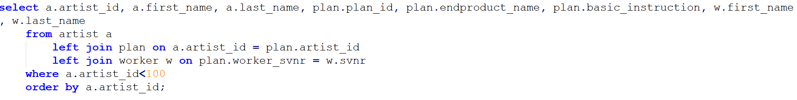

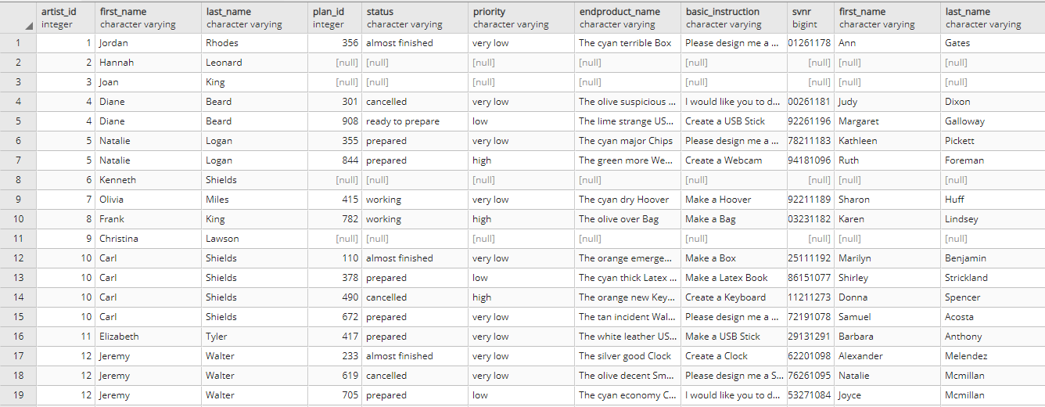

XMLSQL

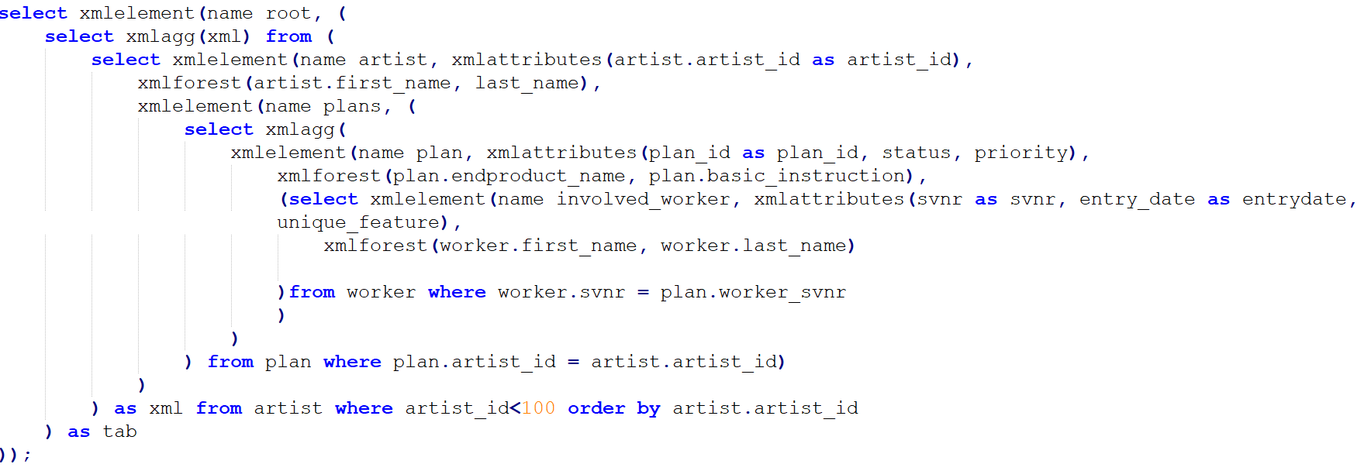

<root>

<artist artist_id="1">

<first_name>Jordan</first_name>

<last_name>Rhodes</last_name>

<plans>

<plan plan_id="356" status="almost finished" priority="very low">

<endproduct_name>The cyan terrible Box</endproduct_name>

<basic_instruction>Please design me a Box</basic_instruction>

<involved_worker svnr="5501261178" entrydate="2013-08-18" unique_feature="self-confident">

<first_name>Ann</first_name>

<last_name>Gates</last_name>

</involved_worker>

</plan>

</plans>

</artist>

<artist artist_id="2">

<first_name>Hannah</first_name>

<last_name>Leonard</last_name>

<plans/>

</artist>

<artist artist_id="3">

<first_name>Joan</first_name>

<last_name>King</last_name>

<plans/>

</artist>

<artist artist_id="4">

<first_name>Diane</first_name>

<last_name>Beard</last_name>

<plans>

<plan plan_id="301" status="cancelled" priority="very low">

<endproduct_name>The olive suspicious Smartphone</endproduct_name>

<basic_instruction>I would like you to do for me a STL file with Smartphone</basic_instruction>

<involved_worker svnr="1200261181" entrydate="2016-06-09" unique_feature="dull">

<first_name>Judy</first_name>

<last_name>Dixon</last_name>

</involved_worker>

</plan>

<plan plan_id="908" status="ready to prepare" priority="low">

<endproduct_name>The lime strange USB Stick</endproduct_name>

<basic_instruction>Create a USB Stick</basic_instruction>

<involved_worker svnr="6592261196" entrydate="2014-01-14" unique_feature="cautious">

<first_name>Margaret</first_name>

<last_name>Galloway</last_name>

</involved_worker>

</plan>

</plans>

</artist>

<artist artist_id="5">

<first_name>Natalie</first_name>

<last_name>Logan</last_name>

<plans>

<plan plan_id="355" status="prepared" priority="very low">

<endproduct_name>The cyan major Chips</endproduct_name>

<basic_instruction>Please design me a Chips</basic_instruction>

<involved_worker svnr="7678211183" entrydate="2015-08-17" unique_feature="sensible">

<first_name>Kathleen</first_name>

<last_name>Pickett</last_name>

</involved_worker>

</plan>

<plan plan_id="844" status="prepared" priority="high">

<endproduct_name>The green more Webcam</endproduct_name>

<basic_instruction>Create a Webcam</basic_instruction>

<involved_worker svnr="8394181096" entrydate="2018-11-05" unique_feature="moody">

<first_name>Ruth</first_name>

<last_name>Foreman</last_name>

</involved_worker>

</plan>

</plans>

</artist>

<artist artist_id="6">

<first_name>Kenneth</first_name>

<last_name>Shields</last_name>

<plans/>

</artist>

<artist artist_id="7">

<first_name>Olivia</first_name>

<last_name>Miles</last_name>

<plans>

<plan plan_id="415" status="working" priority="very low">

<endproduct_name>The cyan dry Hoover</endproduct_name>

<basic_instruction>Make a Hoover</basic_instruction>

<involved_worker svnr="4092211189" entrydate="2016-01-18" unique_feature="trustworthy">

<first_name>Sharon</first_name>

<last_name>Huff</last_name>

</involved_worker>

</plan>

</plans>

</artist>

<artist artist_id="8">

<first_name>Frank</first_name>

<last_name>King</last_name>

<plans>

<plan plan_id="782" status="working" priority="high">

<endproduct_name>The olive over Bag</endproduct_name>

<basic_instruction>Make a Bag</basic_instruction>

<involved_worker svnr="3503231182" entrydate="2014-10-02" unique_feature="selfish">

<first_name>Karen</first_name>

<last_name>Lindsey</last_name>

</involved_worker>

</plan>

</plans>

</artist>

<artist artist_id="9">

<first_name>Christina</first_name>

<last_name>Lawson</last_name>

<plans/>

</artist>

<artist artist_id="10">

<first_name>Carl</first_name>

<last_name>Shields</last_name>

<plans>

<plan plan_id="110" status="almost finished" priority="very low">

<endproduct_name>The orange emergency Box</endproduct_name>

<basic_instruction>Make a Box</basic_instruction>

<involved_worker svnr="4725111192" entrydate="2016-06-08" unique_feature="ambitious">

<first_name>Marilyn</first_name>

<last_name>Benjamin</last_name>

</involved_worker>

</plan>

<plan plan_id="378" status="prepared" priority="low">

<endproduct_name>The cyan thick Latex Book</endproduct_name>

<basic_instruction>Make a Latex Book</basic_instruction>

<involved_worker svnr="4686151077" entrydate="2016-07-24" unique_feature="sensible">

<first_name>Shirley</first_name>

<last_name>Strickland</last_name>

</involved_worker>

</plan>

<plan plan_id="490" status="cancelled" priority="high">

<endproduct_name>The orange new Keyboard</endproduct_name>

<basic_instruction>Create a Keyboard</basic_instruction>

<involved_worker svnr="8211211273" entrydate="2014-02-07" unique_feature="cheerful">

<first_name>Donna</first_name>

<last_name>Spencer</last_name>

</involved_worker>

</plan>

<plan plan_id="672" status="prepared" priority="very low">

<endproduct_name>The tan incident Wallet</endproduct_name>

<basic_instruction>Please design me a Wallet</basic_instruction>

<involved_worker svnr="8872191078" entrydate="2015-07-13" unique_feature="strict">

<first_name>Samuel</first_name>

<last_name>Acosta</last_name>

</involved_worker>

</plan>

</plans>

</artist>

<artist artist_id="11">

<first_name>Elizabeth</first_name>

<last_name>Tyler</last_name>

<plans>

<plan plan_id="417" status="prepared" priority="very low">

<endproduct_name>The white leather USB Stick</endproduct_name>

<basic_instruction>Make a USB Stick</basic_instruction>

<involved_worker svnr="3529131291" entrydate="2014-09-05" unique_feature="big-headed">

<first_name>Barbara</first_name>

<last_name>Anthony</last_name>

</involved_worker>

</plan>

</plans>

</artist>

<artist artist_id="12">

<first_name>Jeremy</first_name>

<last_name>Walter</last_name>

<plans>

<plan plan_id="233" status="almost finished" priority="very low">

<endproduct_name>The silver good Clock</endproduct_name>

<basic_instruction>Create a Clock</basic_instruction>

<involved_worker svnr="3262201098" entrydate="2013-04-14" unique_feature="flirtatious">

<first_name>Alexander</first_name>

<last_name>Melendez</last_name>

</involved_worker>

</plan>

<plan plan_id="619" status="cancelled" priority="very low">

<endproduct_name>The olive decent Smartphone</endproduct_name>

<basic_instruction>Please design me a Smartphone</basic_instruction>

<involved_worker svnr="9776261095" entrydate="2016-05-03" unique_feature="polite">

<first_name>Natalie</first_name>

<last_name>Mcmillan</last_name>

</involved_worker>

</plan>

<plan plan_id="705" status="prepared" priority="low">

<endproduct_name>The cyan economy Clock</endproduct_name>

<basic_instruction>I would like you to do for me a STL file with Clock</basic_instruction>

<involved_worker svnr="8153271084" entrydate="2017-11-02" unique_feature="very cruel">

<first_name>Joyce</first_name>

<last_name>Mcmillan</last_name>

</involved_worker>

</plan>

<plan plan_id="714" status="cancelled" priority="medium">

<endproduct_name>The red resident Chips</endproduct_name>

<basic_instruction>I would like you to do for me a STL file with Chips</basic_instruction>

<involved_worker svnr="6290221080" entrydate="2015-11-08" unique_feature="kind">

<first_name>Danielle</first_name>

<last_name>Keller</last_name>

</involved_worker>

</plan>

</plans>

</artist>

</root>

# Query 4

SQL

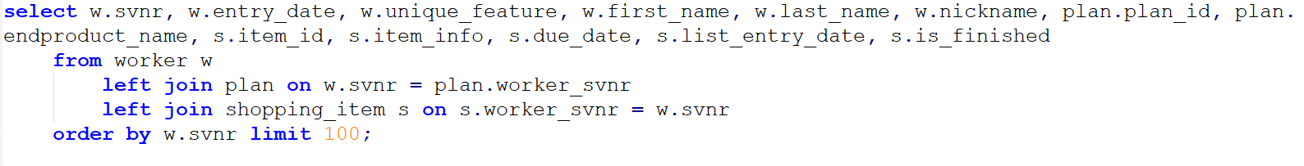

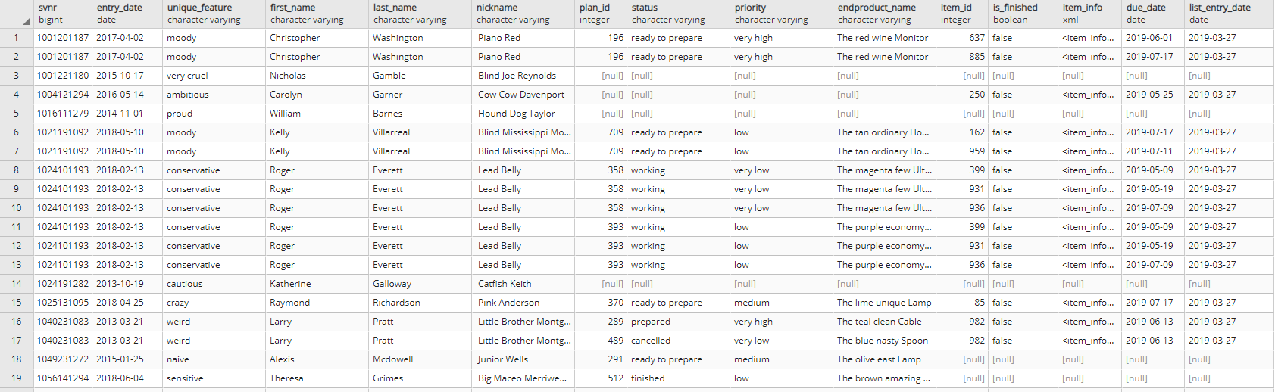

XMLSQL

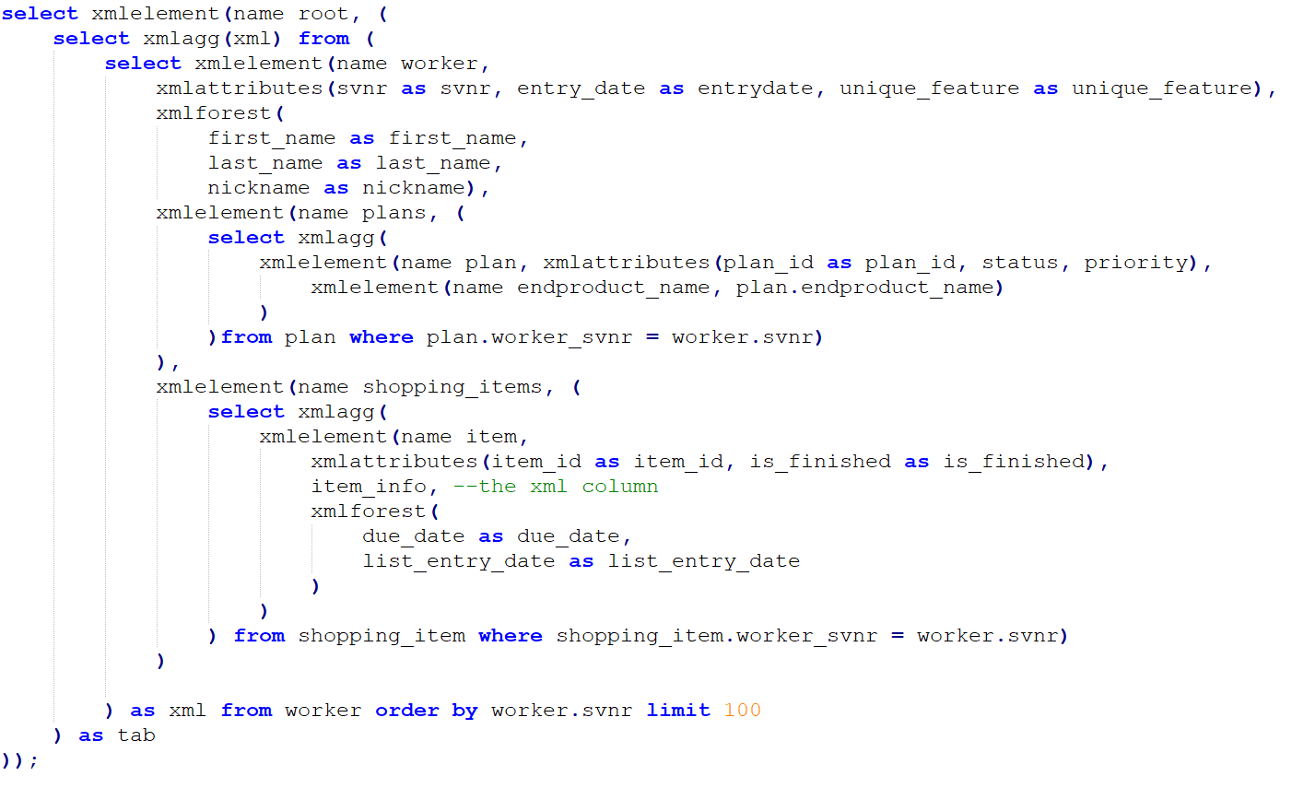

<root>

<worker svnr="1001201187" entrydate="2017-04-02" unique_feature="moody">

<first_name>Christopher</first_name>

<last_name>Washington</last_name>

<nickname> Piano Red</nickname>

<plans>

<plan plan_id="196" status="ready to prepare" priority="very high">

<endproduct_name>The red wine Monitor</endproduct_name>

</plan>

</plans>

<shopping_items>

<item item_id="637" is_finished="false">

<item_info>

<buying_info>

<seller_suggestion>Etsy</seller_suggestion>

<name>silver Wallet</name>

</buying_info>

<additional_info>Whenever there is a problem... SOLVE IT!</additional_info>

</item_info>

<due_date>2019-06-01</due_date>

<list_entry_date>2019-03-27</list_entry_date>

</item>

<item item_id="885" is_finished="false">

<item_info>

<buying_info>

<seller_suggestion>Kohls</seller_suggestion>

<name>orange CD Elton John</name>

</buying_info>

<additional_info>It should be fancy.</additional_info>

</item_info>

<due_date>2019-07-17</due_date>

<list_entry_date>2019-03-27</list_entry_date>

</item>

</shopping_items>

</worker>

<worker svnr="1001221180" entrydate="2015-10-17" unique_feature="very cruel">

<first_name>Nicholas</first_name>

<last_name>Gamble</last_name>

<nickname> Blind Joe Reynolds</nickname>

<plans/>

<shopping_items/>

</worker>

<worker svnr="1004121294" entrydate="2016-05-14" unique_feature="ambitious">

<first_name>Carolyn</first_name>

<last_name>Garner</last_name>

<nickname> Cow Cow Davenport</nickname>

<plans/>

<shopping_items>

<item item_id="250" is_finished="false">

<item_info>

<buying_info>

<seller_suggestion>Sears</seller_suggestion>

<name>blue Keyboard</name>

</buying_info>

<additional_info>Business informatics rocks!</additional_info>

</item_info>

<due_date>2019-05-25</due_date>

<list_entry_date>2019-03-27</list_entry_date>

</item>

</shopping_items>

</worker>

<worker svnr="1016111279" entrydate="2014-11-01" unique_feature="proud">

<first_name>William</first_name>

<last_name>Barnes</last_name>

<nickname> Hound Dog Taylor</nickname>

<plans/>

<shopping_items/>

</worker>

<worker svnr="1021191092" entrydate="2018-05-10" unique_feature="moody">

<first_name>Kelly</first_name>

<last_name>Villarreal</last_name>

<nickname> Blind Mississippi Morris</nickname>

<plans>

<plan plan_id="709" status="ready to prepare" priority="low">

<endproduct_name>The tan ordinary Hoover</endproduct_name>

</plan>

</plans>

<shopping_items>

<item item_id="162" is_finished="false">

<item_info>

<buying_info>

<seller_suggestion>Kohls</seller_suggestion>

<name>yellow Latex Book</name>

</buying_info>

<additional_info>We are the best! Never forget that.</additional_info>

</item_info>

<due_date>2019-07-17</due_date>

<list_entry_date>2019-03-27</list_entry_date>

</item>

<item item_id="959" is_finished="false">

<item_info>

<buying_info>

<seller_suggestion>Kohls</seller_suggestion>

<name>teal Box</name>

</buying_info>

<additional_info>We are the best! Never forget that.</additional_info>

</item_info>

<due_date>2019-07-11</due_date>

<list_entry_date>2019-03-27</list_entry_date>

</item>

</shopping_items>

</worker>

<worker svnr="1024101193" entrydate="2018-02-13" unique_feature="conservative">

<first_name>Roger</first_name>

<last_name>Everett</last_name>

<nickname> Lead Belly</nickname>

<plans>

<plan plan_id="358" status="working" priority="very low">

<endproduct_name>The magenta few Ultrasonic Sensors for Mbot</endproduct_name>

</plan>

<plan plan_id="393" status="working" priority="low">

<endproduct_name>The purple economy Wallet</endproduct_name>

</plan>

</plans>

<shopping_items>

<item item_id="399" is_finished="false">

<item_info>

<buying_info>

<seller_suggestion>Costco</seller_suggestion>

<name>gray Printer</name>

</buying_info>

<additional_info>Make it very nice.</additional_info>

</item_info>

<due_date>2019-05-09</due_date>

<list_entry_date>2019-03-27</list_entry_date>

</item>

<item item_id="931" is_finished="false">

<item_info>

<buying_info>

<seller_suggestion>Amazon</seller_suggestion>

<name>blue Chips</name>

</buying_info>

<additional_info>Business informatics rocks!</additional_info>

</item_info>

<due_date>2019-05-19</due_date>

<list_entry_date>2019-03-27</list_entry_date>

</item>

<item item_id="936" is_finished="false">

<item_info>

<buying_info>

<seller_suggestion>Ebay</seller_suggestion>

<name>silver Printer</name>

</buying_info>

<additional_info>Business informatics rocks!</additional_info>

</item_info>

<due_date>2019-07-09</due_date>

<list_entry_date>2019-03-27</list_entry_date>

</item>

</shopping_items>

</worker>

<worker svnr="1024191282" entrydate="2013-10-19" unique_feature="cautious">

<first_name>Katherine</first_name>

<last_name>Galloway</last_name>

<nickname> Catfish Keith</nickname>

<plans/>

<shopping_items/>

</worker>

<worker svnr="1025131095" entrydate="2018-04-25" unique_feature="crazy">

<first_name>Raymond</first_name>

<last_name>Richardson</last_name>

<nickname> Pink Anderson</nickname>

<plans>

<plan plan_id="370" status="ready to prepare" priority="medium">

<endproduct_name>The lime unique Lamp</endproduct_name>

</plan>

</plans>

<shopping_items>

<item item_id="85" is_finished="false">

<item_info>

<buying_info>

<seller_suggestion>Amazon</seller_suggestion>

<name>olive Box</name>

</buying_info>

<additional_info>Whenever there is a problem... SOLVE IT!</additional_info>

</item_info>

<due_date>2019-07-17</due_date>

<list_entry_date>2019-03-27</list_entry_date>

</item>

</shopping_items>

</worker>

<worker svnr="1040231083" entrydate="2013-03-21" unique_feature="weird">

<first_name>Larry</first_name>

<last_name>Pratt</last_name>

<nickname> Little Brother Montgomery</nickname>

<plans>

<plan plan_id="289" status="prepared" priority="very high">

<endproduct_name>The teal clean Cable</endproduct_name>

</plan>

<plan plan_id="489" status="cancelled" priority="very low">

<endproduct_name>The blue nasty Spoon</endproduct_name>

</plan>

</plans>

<shopping_items>

<item item_id="982" is_finished="false">

<item_info>

<buying_info>

<seller_suggestion>Etsy</seller_suggestion>

<name>lime Bag</name>

</buying_info>

<additional_info>Whenever there is a problem... SOLVE IT!</additional_info>

</item_info>

<due_date>2019-06-13</due_date>

<list_entry_date>2019-03-27</list_entry_date>

</item>

</shopping_items>

</worker>

<worker svnr="1049231272" entrydate="2015-01-25" unique_feature="naive">

<first_name>Alexis</first_name>

<last_name>Mcdowell</last_name>

<nickname> Junior Wells</nickname>

<plans>

<plan plan_id="291" status="ready to prepare" priority="medium">

<endproduct_name>The olive east Lamp</endproduct_name>

</plan>

</plans>

<shopping_items/>

</worker>

<worker svnr="1056141294" entrydate="2018-06-04" unique_feature="sensitive">

<first_name>Theresa</first_name>

<last_name>Grimes</last_name>

<nickname> Big Maceo Merriweather</nickname>

<plans>

<plan plan_id="512" status="finished" priority="low">

<endproduct_name>The brown amazing Hoover</endproduct_name>

</plan>

<plan plan_id="517" status="finished" priority="high">

<endproduct_name>The silver actual Keyboard</endproduct_name>

</plan>

</plans>

<shopping_items/>

</worker>

</root>